

|  |  |  |  |  |  |
| --- | --- | --- | --- | --- | --- |
| Programme | : | **B.Tech.** | Semester | : | **Fall 22-23** |
| Course | : | **CSE3002:**  **Internet and Web Programming Lab** | Slot | : | **L9+L10** |
| Faculty | : | **Dr. M. Premalatha** | Marks | : | **10** |

**Date: 01-11-2022**

Advait Deochakke

20BCE1143

**Exercise –8**

XML

**Note:**

1. **View your registration number in the title bar and snap a screenshot of output along with the title bar.**
2. **Screenshot is required for every modifications of the web page.**
3. Apply styles as below using XML & CSS

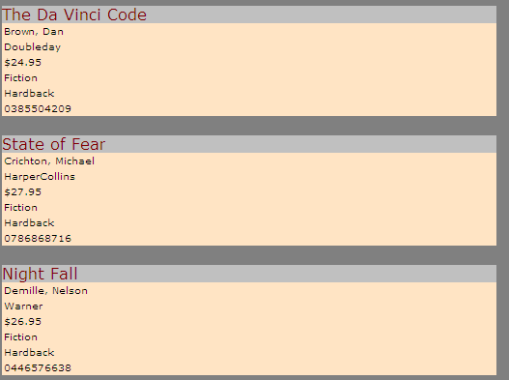

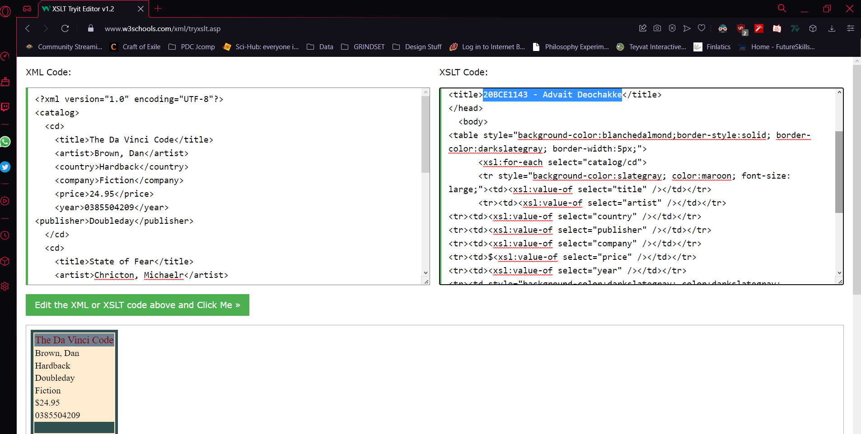

**XML Code:**

<?xml version="1.0" encoding="UTF-8"?>

<catalog>

<cd>

<title>The Da Vinci Code</title>

<artist>Brown, Dan</artist>

<country>Hardback</country>

<company>Fiction</company>

<price>24.95</price>

<year>0385504209</year>

<publisher>Doubleday</publisher>

</cd>

<cd>

<title>State of Fear</title>

<artist>Chricton, Michaelr</artist>

<country>Hardback</country>

<company>Fiction</company>

<price>27.95</price>

<year>0786886871</year>

<publisher>HarperCollins</publisher>

</cd>

<cd>

<title>Nightfall</title>

<artist>Damille, Nelson</artist>

<country>Hardback</country>

<company>Fiction</company>

<price>24.95</price>

<year>046657638</year>

<publisher>Warner</publisher>

</cd>

</catalog>

**XSLT Code:**

<?xml version="1.0" encoding="UTF-8"?>

<xsl:stylesheet version="1.0"

xmlns:xsl="http://www.w3.org/1999/XSL/Transform">

<xsl:template match="/">

<html>

<head>

<title>20BCE1143 - Advait Deochakke</title>

</head>

<body>

<table style="background-color:blanchedalmond;border-style:solid; border-color:darkslategray; border-width:5px;">

<xsl:for-each select="catalog/cd">

<tr style="background-color:slategray; color:maroon; font-size: large;"><td><xsl:value-of select="title" /></td></tr>

<tr><td><xsl:value-of select="artist" /></td></tr>

<tr><td><xsl:value-of select="country" /></td></tr>

<tr><td><xsl:value-of select="publisher" /></td></tr>

<tr><td><xsl:value-of select="company" /></td></tr>

<tr><td>$<xsl:value-of select="price" /></td></tr>

<tr><td><xsl:value-of select="year" /></td></tr>

<tr><td style="background-color:darkslategray; color:darkslategray; ">blank</td></tr>

</xsl:for-each>

</table>

</body>

</html>

</xsl:template>

</xsl:stylesheet>

1. Apply XML DTD and XML Schema for the above Books Database

**DTD :**

<!DOCTYPE CATALOG [

<!ELEMENT CATALOG (CD+)>

<!ELEMENT CD (title+, artist+, country+, company+, price?, year+, publisher+)>

<!ATTLIST CD

    title (#PCDATA)

    artist (#pcdata)

    country (Hardback|Paperback|Ebook) "Hardback"

    company (Fiction|Thriller|Biography|Literature) "Fiction"

    price (#PCDATA)

    year (#pcdata)

    publisher (HarperCollins|Doubleday|Warner)

>

]>

**Schema :**

<?xml version="1.0" encoding="UTF-8" ?>

<xs:schema xmlns:xs="http://www.w3.org/2001/XMLSchema">

<!-- definition of simple elements -->

<xs:element name="title" type="xs:string"/>

<xs:element name="artist" type="xs:string"/>

<xs:element name="country" type="xs:string"/>

<xs:element name="company" type="xs:string"/>

<xs:element name="price" type="xs:decimal"/>

<xs:element name="year" type="xs:integer"/>

<xs:element name="publisher" type="xs:string"/>

<!-- definition of complex elements -->

<xs:element name="cd">

  <xs:complexType>

    <xs:sequence>

      <xs:element ref="title" maxOccurs="1" minOccurs="1"/>

      <xs:element ref="artist" maxOccurs="1" minOccurs="1"/>

      <xs:element ref="country" maxOccurs="1" minOccurs="1"/>

      <xs:element ref="company" maxOccurs="1" minOccurs="1"/>

      <xs:element ref="price" maxOccurs="1" minOccurs="0"/>

      <xs:element ref="year" maxOccurs="1" minOccurs="1"/>

      <xs:element ref="publisher" maxOccurs="1" minOccurs="1"/>

    </xs:sequence>

  </xs:complexType>

</xs:element>

<xs:element name="catalog">

  <xs:complexType>

    <xs:sequence>

      <xs:element ref="cd" maxOccurs="unbounded"/>

    </xs:sequence>

  </xs:complexType>

</xs:element>

</xs:schema>

1. Consider the following XML DTD

<?xml version="1.0"?>

<!-- 1. XML-Document -->

<!DOCTYPE catalog SYSTEM "cat.dtd">

<catalog>

<product>

<productname>cupboard</productname>

<storagenumber>3421</storagenumber>

<dimension unit="cm">

<width>120</width>

<heigth>180</heigth>

<depth>34</depth>

</dimension>

<description>oak veneer</description>

</product>

</catalog>

<?xml version="1.0"?>

<!-- 2. XML-Document -->

<!DOCTYPE catalog SYSTEM "cat.dtd">

<catalog>

<product>

<productname>mirror</productname>

<storagenumber>3455</storagenumber>

<dimension unit="m">

<width>1</width>

<heigth>1,5</heigth>

</dimension>

<description>blue frame</description>

<supplier>Schmid Co.</supplier>

<supplier>Mayer GmbH</supplier>

</product>

</catalog>

Deﬁne a possible XML Schema for the 2.XML documents.

**COMMON SCHEMA :**

<?xml version="1.0" encoding="UTF-8" ?>

<xs:schema xmlns:xs="http://www.w3.org/2001/XMLSchema">

<!-- definition of simple elements -->

<xs:element name="height" type="xs:decimal"/>

<xs:element name="width" type="xs:decimal"/>

<xs:element name="depth" type="xs:decimal"/>

<xs:element name="productname" type="xs:string"/>

<xs:element name="storagenumber" type="xs:integer"/>

<xs:element name="description" type="xs:string"/>

<xs:element name="supplier" type="xs:string"/>

<!-- definition of attributes -->

<xs:attribute name="unit" type="xs:string"/>

<!-- definition of complex elements -->

<xs:element name="dimension">

  <xs:complexType>

    <xs:sequence>

      <xs:element ref="height" use="required"/>

      <xs:element ref="width" maxOccurs="1" minOccurs="0"/>

      <xs:element ref="depth" maxOccurs="1" minOccurs="0"/>

      <xs:attribute ref="unit" use="required"/>

    </xs:sequence>

  </xs:complexType>

</xs:element>

<xs:element name="product">

  <xs:complexType>

    <xs:sequence>

      <xs:element ref="productname" use="required"/>

      <xs:element ref="storagenumber" use="required"/>

      <xs:element ref="dimension" use="required"/>

      <xs:element ref="description"/>

      <xs:element ref="supplier"/>

    </xs:sequence>

  </xs:complexType>

</xs:element>

<xs:element name="catalog">

  <xs:complexType>

    <xs:sequence>

      <xs:element ref="product" maxOccurs="unbounded"/>

    </xs:sequence>

  </xs:complexType>

</xs:element>

</xs:schema>

1. Consider now an extension of our original DTD, where the element juicer has attributes.

<!ELEMENT juicers (juicer)*>

<!ELEMENT juicer (name, image, description, warranty?,

weight?, cost+, retailer)>

<!ATTLIST juicer id ID #REQUIRED

electric (true|false) #REQUIRED

type (press | gear | centrifugal) #REQUIRED>

<!ELEMENT name (#PCDATA)>

<!ELEMENT image (#PCDATA)>

<!ELEMENT description (#PCDATA)>

<!ELEMENT warranty (#PCDATA)>

<!ELEMENT weight (#PCDATA)>

<!ELEMENT cost (#PCDATA)>

<!ELEMENT retailer (#PCDATA)>

Create corresponding attributes in the XML schema.

**New Simple Elements :**

<!-- definition of new simple elements -->

<xs:element name="weight" type="xs:decimal"/>

<xs:element name="cost" type="xs:decimal"/>

<xs:element name="warranty" type="xs:string"/>

<xs:element name="retailer" type="xs:string"/>

<xs:element name="image" type="xsd:base64Binary"/>

<!-- definition of new attributes -->

<xs:attribute name="id" type="xs:string">

    <xs:simpleType>

        <xs:restriction base="xs:integer">

            <xs:pattern value="[0-9]+"/>

        </xs:restriction>

    </xs:simpleType>

</xs:attribute>

<xs:attribute name="electric" type="xs:string">

    <xs:simpleType>

        <xs:restriction base="xs:string">

            <xs:pattern value="(\btrue\b|\bfalse\b){1}"/>

        </xs:restriction>

    </xs:simpleType>

</xs:attribute>

<xs:attribute name="type" type="xs:string">

    <xs:simpleType>

        <xs:restriction base="xs:string">

            <xs:pattern value="(\bpress\b|\bgear\b|\bcentrifugal\b){1}"/>

        </xs:restriction>

    </xs:simpleType>

</xs:attribute>

<!-- definition of new complex elements -->

<xs:element name="juicer">

  <xs:complexType>

    <xs:sequence>

      <xs:element ref="productname"/>

      <xs:element ref="image"/>

      <xs:element ref="description"/>

      <xs:element ref="warranty" maxOccurs="1"/>

      <xs:element ref="weight" maxOccurs="1"/>

      <xs:element ref="cost" minOccurs="1"/>

      <xs:element ref="retailer"/>

      <xs:attribute ref="ID" use="required"/>

      <xs:attribute ref="electric" use="required"/>

      <xs:attribute ref="type" use="required"/>

    </xs:sequence>

  </xs:complexType>

</xs:element>

<xs:element name="juicers">

  <xs:complexType>

    <xs:sequence>

      <xs:element ref="juicer" maxOccurs="unbounded"/>

    </xs:sequence>

  </xs:complexType>

</xs:element>

<xs:element name="catalog">

  <xs:complexType>

    <xs:sequence>

      <xs:element ref="product" maxOccurs="unbounded"/>

      <xs:element ref="juicers" maxOccurs="unbounded"/>

    </xs:sequence>

  </xs:complexType>

</xs:element>

**------------------------------------------------------------------------------------------------------------**